**NAAN MUDHALVAN PROJECT**

**EXPLORING WORLD'S TOP YOU TUBE CHANNELS**

**TEAM :**

**R.SWATHI**

**R.RASHIGA**

**A.THASLIM BANU**

**N.DIVYA DHARSHINI**

**OVER VIEW**

**INTRODUCTION :**

A subscriber to a channel on the video-sharing YouTube is a user who has chosen

most-subscribed channels in April 2006. An early archive of the list dates to May 2006.

To receive the channel's content by clicking on that channel's "Subscribe" button,

and each user's subscription feed consists of videos published by channels to which

the user is subscribed. The ability to subscribe to users was introduced in October

2005. YouTube began publishing a list of its

**PURPOSE :**

YouTube is considered a social media platform because you can share content with “followers” (subscribers) and foster communities through interaction and engagement. YouTube is a free video sharing website that makes it easy to watch online videos. You can even create and upload your own videos to share with others.

PROBLEM DEFINITION & DESIGN THINKING

1. EMPATHY MAP

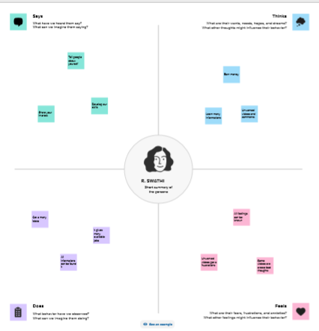

1. BRAIN STORM

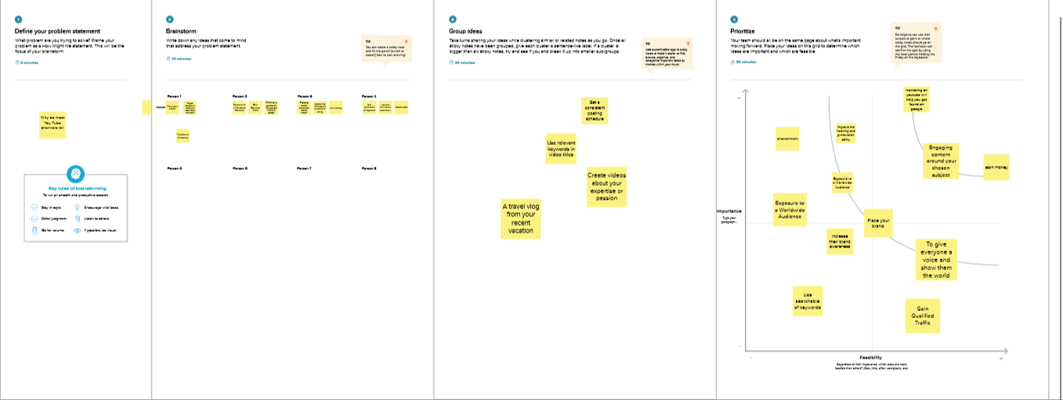

RESULT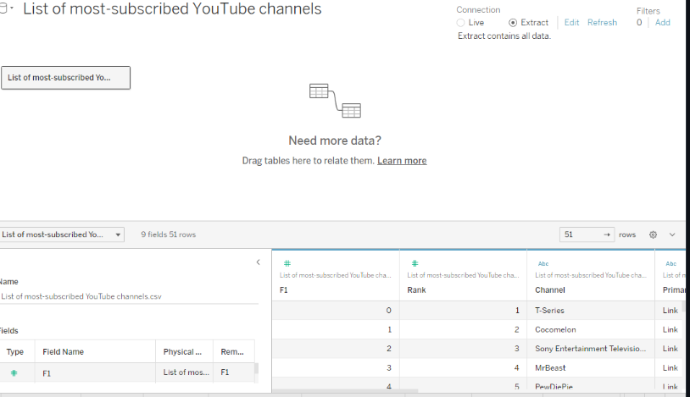

**ADVANTAGES :**

Uploading videos and sharing content is free on youtube. There is no single money is used for uploading any video or making any channel. Liking any video, sharing video, and following any channel will not cost you. If you want a video without any advertisement played then you have an option that is recently added on youtube is a premium subscription in this we have to pay some amount for youtube premium to subscribe to see videos without any advertisement.

**DISADVANTAGES:**

There are some distinct disadvantages of watching YouTube videos, which include a lot of commercials. It is possible to skip your mainstream. However, you're often required to watch commercials lasting between 15 and 20 seconds. This isn't just a time-waster, but it can be irritating at times. Another issue that is associated with YouTube is that it requires you to pay a charge if you would like to view ads-free content.

**APPLICATIONS:**

It’s very easy to use, and it's an amazing tool to promote business, and Share it to everyone. I definitely love YouTube an recommend it to everyone. Some YouTube apps does not allow to upload videos.

**CONCLUSION:**

In conclusion, YouTube is a very strong growing platform creating lots of opportunities for entrepreneurs and motivated people. The best way to succeed at it, apart from creating good video content, is knowing what people like and knowing how to reach those people, for which of course you will need a mastery of social media.

**FUTURE SCOPE:**

**YouTube is ever-changing, whether it's “borrowing” features from other platforms, finding new ways to monetize, or making the platform more accessible to creators and viewers. If YouTube continues on the current path, the future will include more streaming, more e-Commerce initiatives, and more immersive experiences.**